**Title:** An experiment in which a varying electromagnetic field

generates a gravitational field that causes all objects to move

**Authors:** Zhang Xiangqian1*, Xu Yuchuan1*

**Affiliations:**

1Anhui Develop Amorphous Equipment Co., Ltd;

Hefei City, 231500, China

*Xu Yuchuan. Email: info@ahdvlp.com

**Abstract:**

In 1831, the British scientist Michael Faraday's experiment discovered the phenomenon of electromagnetic induction, not only revealed the intrinsic connection between electricity and magnetism, but also realized the mutual transformation of magnetism and electricity, from which mankind entered the era of electric civilization. Since then, more scientists have delved into the fundamental laws of electricity and magnetism. German scientist Albert Einstein had even spent more than 40 years trying to unify electricity, magnetism and gravity, but unfortunately he didn't succeed. This test is an attempt to link electricity, magnetism and gravity.

**Main Text:**

Test method: A soft magnetic toroidal core made of amorphous material is selected, the saturation magnetic induction strength of the amorphous material is Bs = 1.25 tesla (T), the permeability is greater than or equal to 100000. The inner diameter of the core is 130 mm, the outer diameter is 190 mm, and the height is 30 mm. Cutting a 18 mm length incision on the toroidal core to form a 18 mm long air gap. A 400-turn excitation winding covering the toroidal core is made of enameled copper wire with a diameter of 2.0 mm. Refer to Fig.1. and Fig.2.

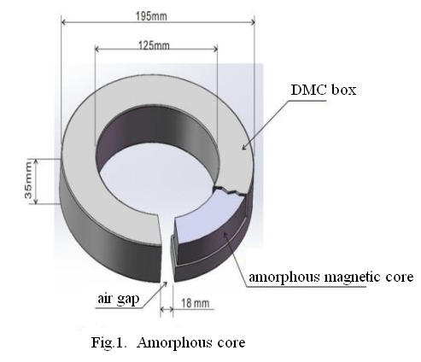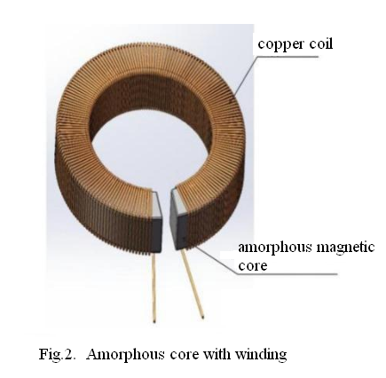

Switching on the coil with AC of frequency f = 50 Hz and voltage V = 50 to 100 volts (adjusting the input voltage with a voltage regulator), and the coil winding current I = 10 A to 50A, which generates an alternating flux at the air gap of the core, and the strength of the magnetic field at the air gap is about 0.2 to 0.5 Tesla (T).

Under normal temperature and normal atmospheric pressure environment, suspending the test material in the air gap by a thin cotton thread, after the coil is energized, it is found that the object of all materials can be moved. Refer to Fig.3.

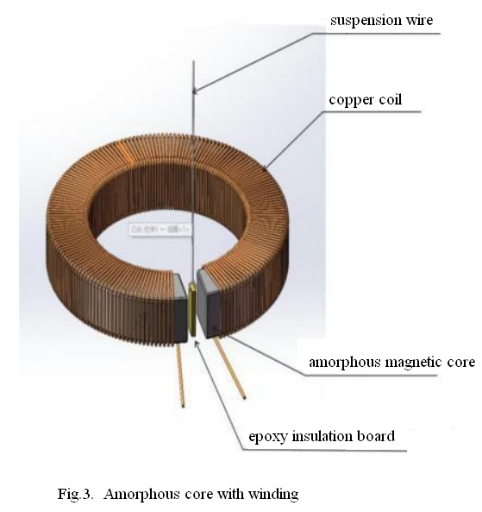

Test materials (the motion effect is obvious when a thin rectangular material is selected) :

1. Epoxy insulating board (Length 41mm×Width 12.5mm×Thickness 1.5mm, Weight 1.5g)
2. Paper (Length 37mm×Width 12.5mm×Thickness 0.11mm, Weight 50mg)
3. Ceramic (Length 30mm×Width 9mm×Thickness 4.0mm, Weight 1.5g)
4. Green leaves (Length 38mm×Width 14mm×Thickness 0.3mm, Weight 125mg)
5. Aluminum plate (Length 40mm×Width 12mm×Thickness 2.0mm, Weight 2g)
6. Fresh pork skin (Length 20mm×Width 10mm×Thickness 3.0mm, Weight 0.5g)

After the analysis of the motion of objects at the air gap magnetic field, it is found that a gravitational field is generated at the air gap, which makes the objects of all materials placed in it move. Refer to Fig.4.

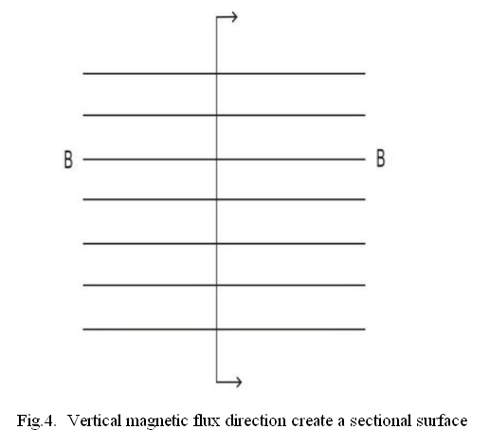

Taking any point on the vertical profile of the air gap magnetic flux, and the direction of the gravitational force on this point may be perpendicular to the direction of the magnetic field from around this point, and converge towards this investigation point, refer to Fig.5. and Fig.6. for gravitational direction.

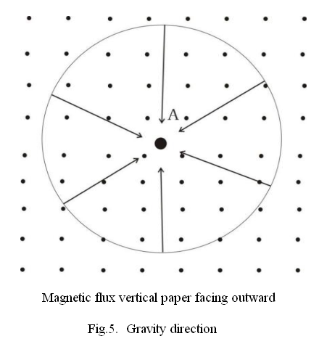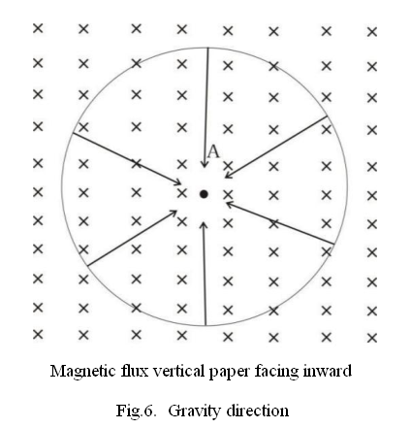

In the process of this experiment, the influence of the vibration after the energized amorphous core and the influence of airflow disturbance in the air gap have been fully weakened, if we use 20V to 60V DC through the coil to instead of AC, the effect of the object movement is the same. Refer to Fig.7.

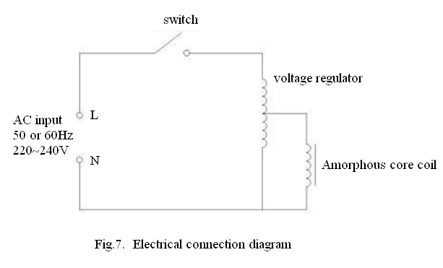

If the reader wants to repeat the experiment, amorphous iron core may not be selected, you can use silicon steel iron core, coil 400 to 500 turns, with 50HZ or 60HZ AC input coil, the voltage between 50V and 100V, and then the motion effect of the object can be observed. The experiment generated a gravitational field, now according to the experimental motion effect, the mathematical formula of gravitational field is given as follows:

Differential formula ∇×A= B

A is the gravitational field intensity, k is a constant, and B is the magnetic induction intensity.

Integral formula ∲A∙dl= ∯B∙ds

A is the gravitational field intensity, k is a constant, and B is the magnetic induction intensity.

**Reference：**Unified Field Theory: Extraterrestrial Technology -- Academic Edition (2nd) <https://a.co/d/d5sVWrT>

**Acknowledgments:**

Editors: Zhang Chuanxiang, Shu Xiuxia, Li Chuanquan, Wang Jinwu

Translator: Jiang Yuanyuan

**Funding:** Anhui Develop Amorphous Equipment Co., Ltd

**Author contributions:**

Theoretical guidance: Zhang Xiangqian

Experimental design: XU Yuchuan

Manuscript - Original manuscript: Zhang Xiangqian, Xu Yuchuan

Manuscript - Review and editing: Zhang Xiangqian, Xu Yuchuan, Zhang Chuanxiang, Shu Xiuxia, Jiang Yuanyuan

**Competing interests:** It is hereby declared that Zhang Xiangqian and Xu Yuchuan have no competing interests

**Data and materials availability:** All data can be obtained in the main text or in supplementary materials.

**Supplementary Materials:**

Videos of different test materials (epoxy insulating board, paper, ceramic, green leaves, aluminum plate, fresh pork skin) motion in the magnetic field under the action of gravity after the coil is energized.

Supplementary Materials

An experiment in which a varying electromagnetic field generates a gravitational field that causes all objects to move

Zhang Xiangqian, Xu Yuchuan

Xu Yuchuan Email: info@ahdvlp.com

Videos of different test materials (epoxy insulating board, paper, ceramic, green leaves, aluminum plate, fresh pork skin) motion in the magnetic field under the action of gravity after the coil is energized.

Movie S1: Video of epoxy insulating board motion in the magnetic field under the action of gravity after the coil is energized.



Movie S2: Video of paper motion in the magnetic field under the action of gravity after the coil is energized.



Movie S3: Video of ceramic motion in the magnetic field under the action of gravity after the coil is energized.



Movie S4: Video of green leaves motion in the magnetic field under the action of gravity after the coil is energized.



Movie S5: Video of aluminum plate motion in the magnetic field under the action of gravity after the coil is energized.



Movie S6: Video of fresh pork skin motion in the magnetic field under the action of gravity after the coil is energized.

